Log Analytics Loggroup with ORM stack

Contents

1. Introduction 3
2. Workflow diagram to deploy the stack 3
3. Create stack for Log analytics Loggroup 4
4. Plan the Job 6
5. Apply the Job 7
6. Verify in the Console 8
7. Destroy the stack 10

Introduction

This resource provides the Log Analytics Log Group resource in Oracle Cloud Infrastructure Log Analytics service.Creates a new log group in the specified compartment with the input display name. Log Groups are located in a compartment to provide user access control to logs stored in that log group.

Workflow diagram to deploy the stack

Below diagram shows how the Terraform Artifact are applied in the OCI. While creating a ORM stack, using terraform deliverables Init, Plan and Apply is the flow to provision the resource in the OCI. We can have the deliverables in any of below.

- GitLab/GitHub Repo
- Bitbucket
- Can be in folder/.zip in the local disk
- Object Storage Bucket
- Can be in compartment
- Oracle provided Template

Pre-request
- Create a Object storage bucket

Create stack for Log analytics Loggroup

Go to OCI Console Developer Services Resource Manager Stacks select the compartment Create Stack

My Configuration Folder Browse Select the “Log_analytics_group” folder that contains the terraform Upload

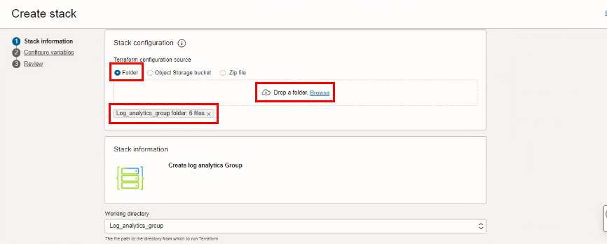

Select the parameters as per the below screen,
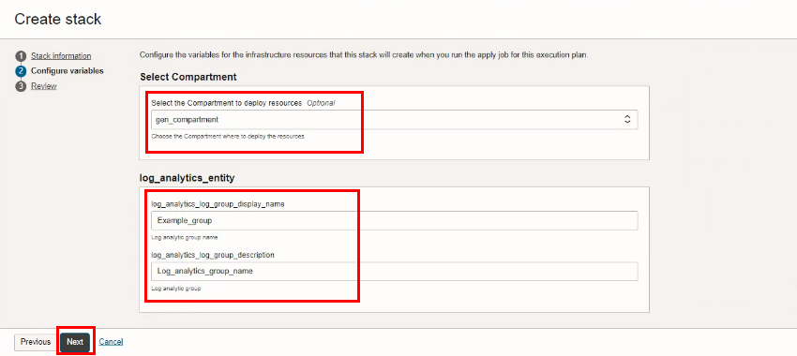
Click “NEXT”
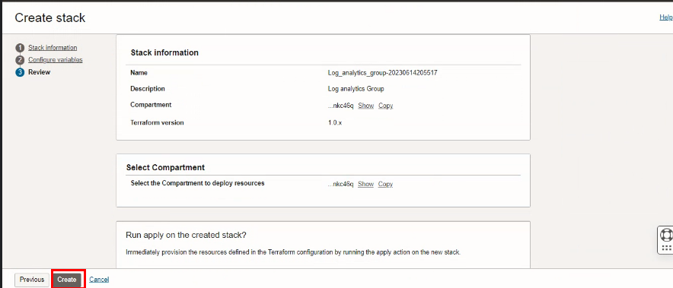
Click “CREATE”

Plan the Job

Click the “Plan”
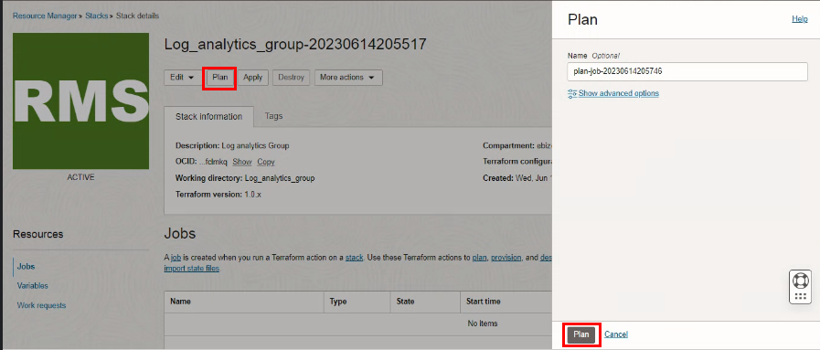

Verify the Plan is successful.
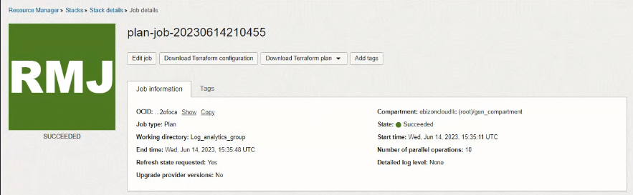

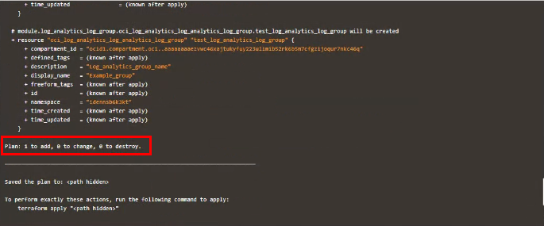

- Apply the Job

Once the “plan” is success, now click “Apply”
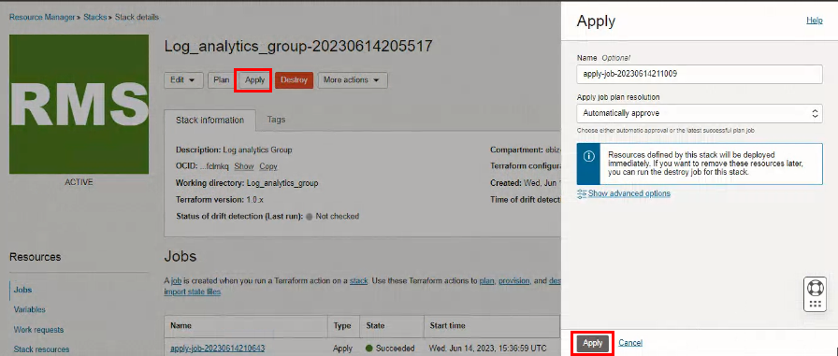

Verify the Apply is successful.
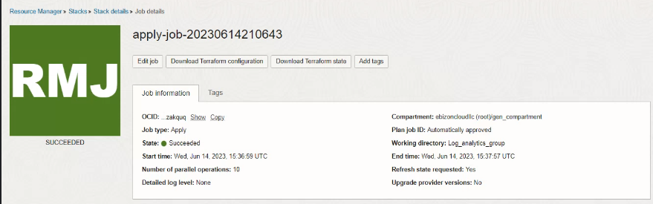

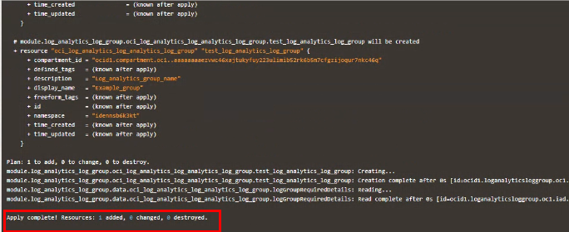

Verify in the Console

Go to OCI Console Observability & Management Logging AnalyticsAdministration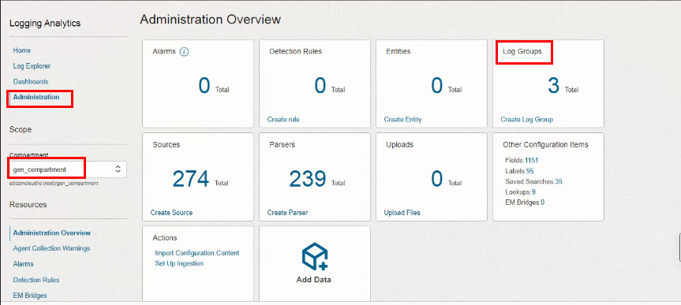

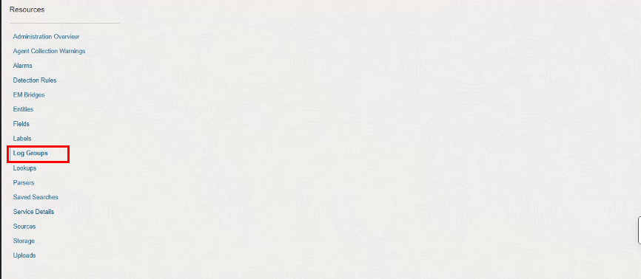

Go to OCI Console Observability & Management Logging Analytics Administration Loggroup
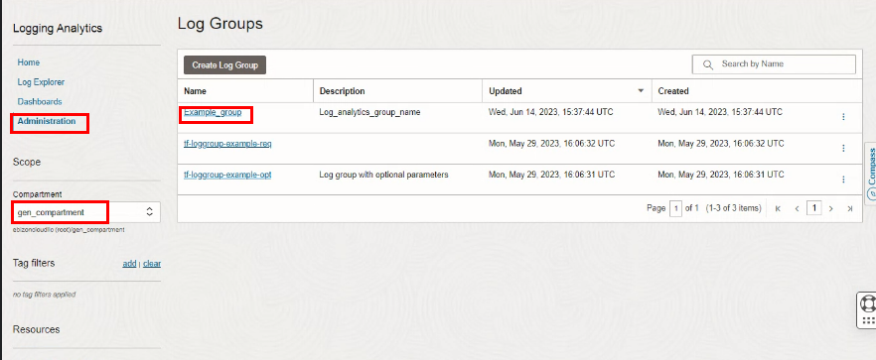

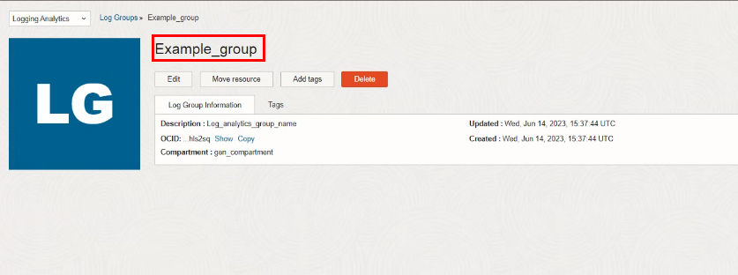

Destroy the stack

Create a destroy job in Resource Manager to release resources associated with a stack and clean up the tenancy. Once destroyed data cannot be recovered from resources.
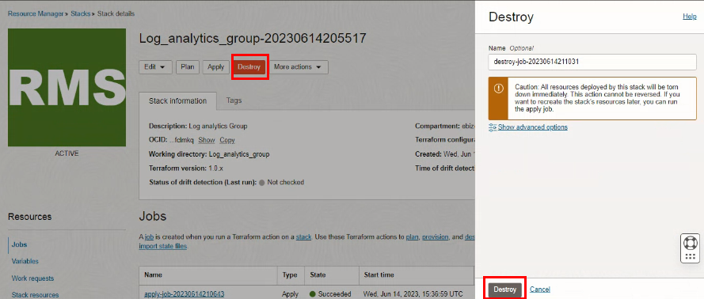

#END#

